**Html**

**Html:** HTML Stands for Hyper Text Markup Language. HTML code will have the file

extension as .html.It is used to write User Interface for Web Development programs.

Example code:

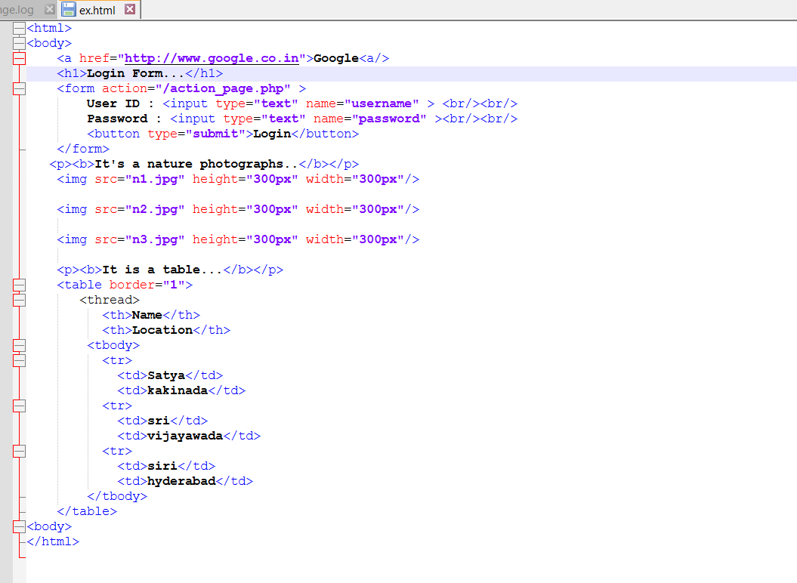

Output:



Code1:

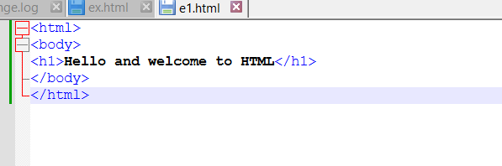

Output:

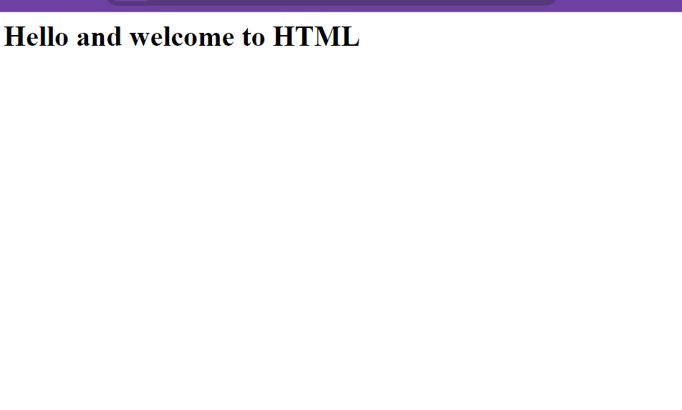

**Html elements:**

HTML documents are composed of elements, which include a start tag, content, and an end tag. The format is: <tag> Content </tag>

ex:<h1>Welcome to HTML!</h1>

In this case, <h1> is the start tag, Welcome to HTML! is the content, and </h1> is the end tag. The tags are not case-sensitive.

**Nested elements:**

HTML elements can be nested within each other, which is known as nesting.

ex: the <p> tag is used for paragraphs, and both <h1> and <p> tags can be nested inside the <body> tag, which defines the body of the HTML document.

**Code for nesting elements:**

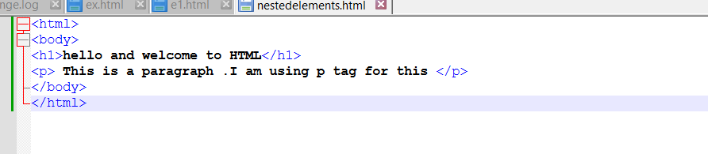

**Output:**



**Html attributes:**

HTML elements can have attributes that provide additional information. Attributes are specified in the start tag of the element and are always in key-value pairs, such as width="200", where width is the key and 200 is the value.  
  
HTML attributes code:

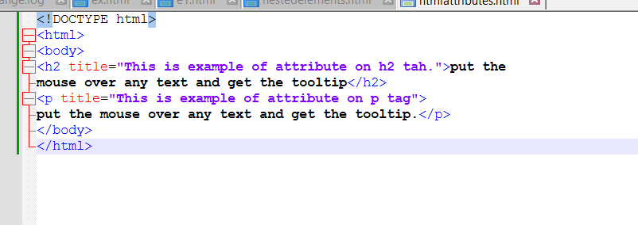

Output:



The title attribute can be used with both <h1> and <p> tags. It displays a tooltip when the user hovers over the element.

For example, <h1 title="Example of H1 tag">Header</h1> will show "Example of H1 tag" as a tooltip when hovered. Similarly, <p title="Example of P1 title">Paragraph</p> will show "Example of P1 title" when hovered.

**Html src attribute:**

The <img> element uses the src attribute to specify the image file's location and name. It doesn't have an end tag; instead, it is self-closing with />, like this:

**<img src="image.jpg"/>**

**Src attribute code:**

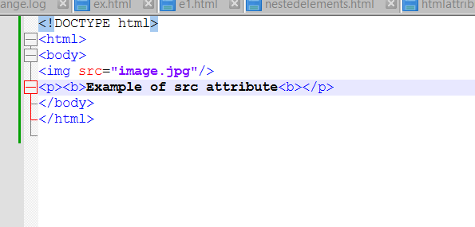

**Output:**

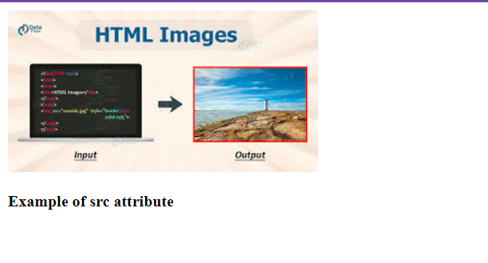

**HTML Attributes – height and width:**

In the <img> element, along with the src attribute, you can also specify height and width attributes in pixels.

Ex:<img src="image.jpg" height="300" width="300"/>

This sets the image size to 300x300 pixels. The <p> tag is used to write paragraphs.

**Html-attributewith height and width code:**

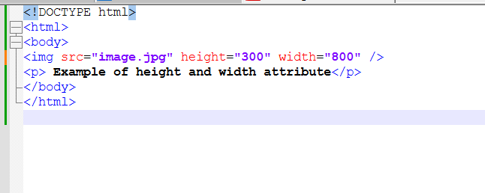

**Output:**

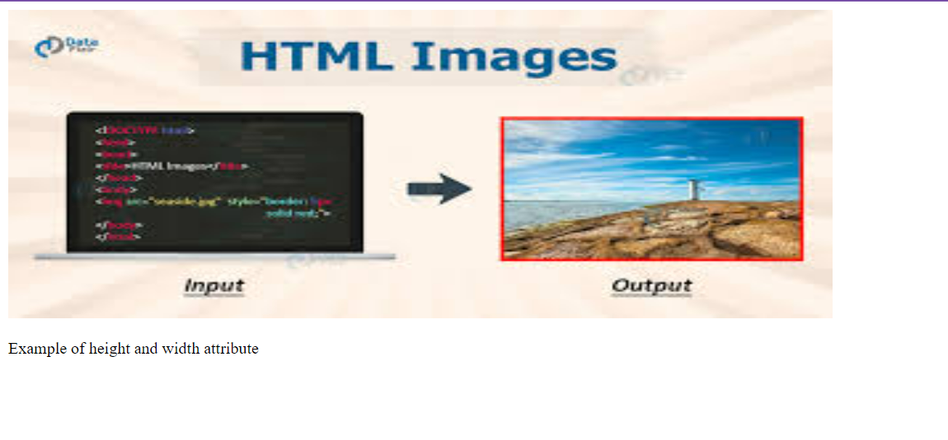

**Html alt attribute:**

The alt attribute in the <img> tag provides an alternative text message if the image cannot be displayed, such as due to a missing file or a slow internet connection. For example:

<img src="a.jpg" alt="Sorry! The image is not available"/>

Htmlalt code:

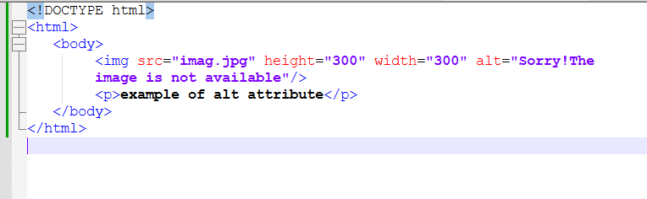

Output:

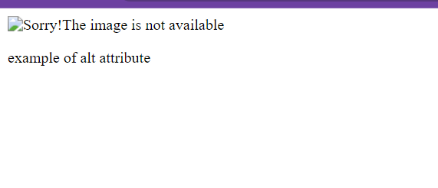

**HTML Header:**

The <head> tag contains all the header elements of an HTML document. The <title> tag sets the webpage's title, such as "My Data". Other tags that can be included in the <head> are:

* <style>: Specifies CSS styles.
* <script>: For JavaScript or jQuery scripts.
* <link>: Links to an external stylesheet.

Header code:

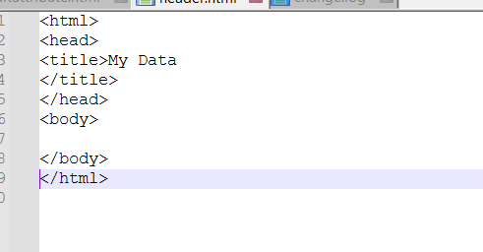

Output:

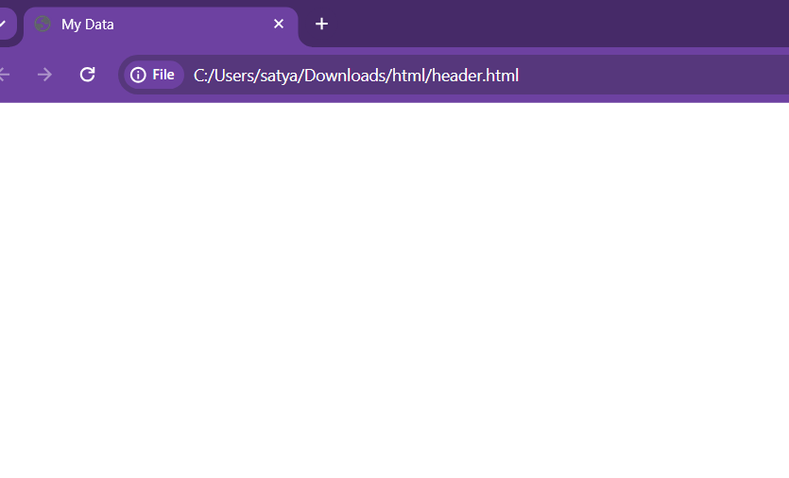

HTML provides six header tags, H1 to H6. H1 displays the largest header, and H6 displays the smallest. Each subsequent header tag (H2 to H6) displays text in progressively smaller sizes compared to the previous header tag.

Multiple headers code:

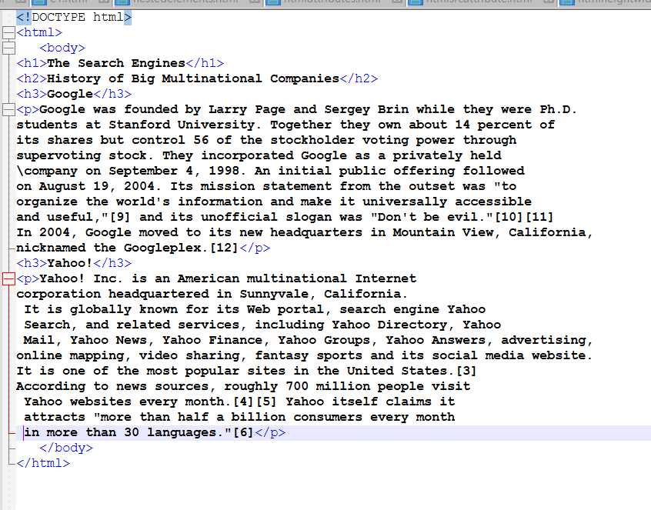

Output:

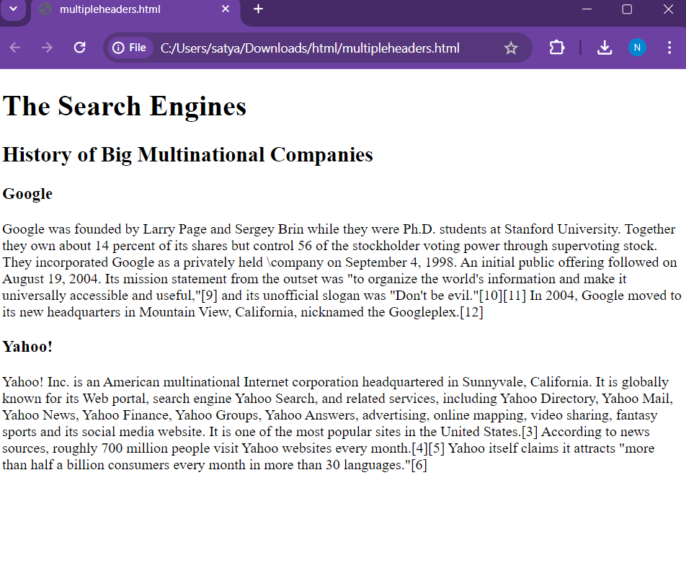

**HR tag is used to display horizontal line as show below:**

**Hrheadercode:**

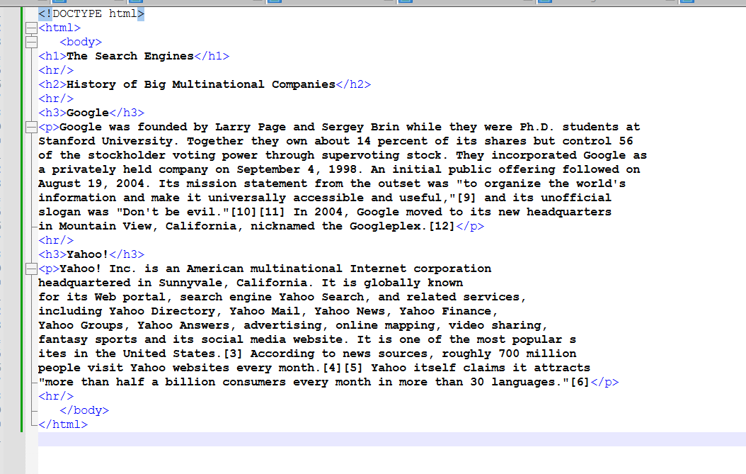

**Output:**

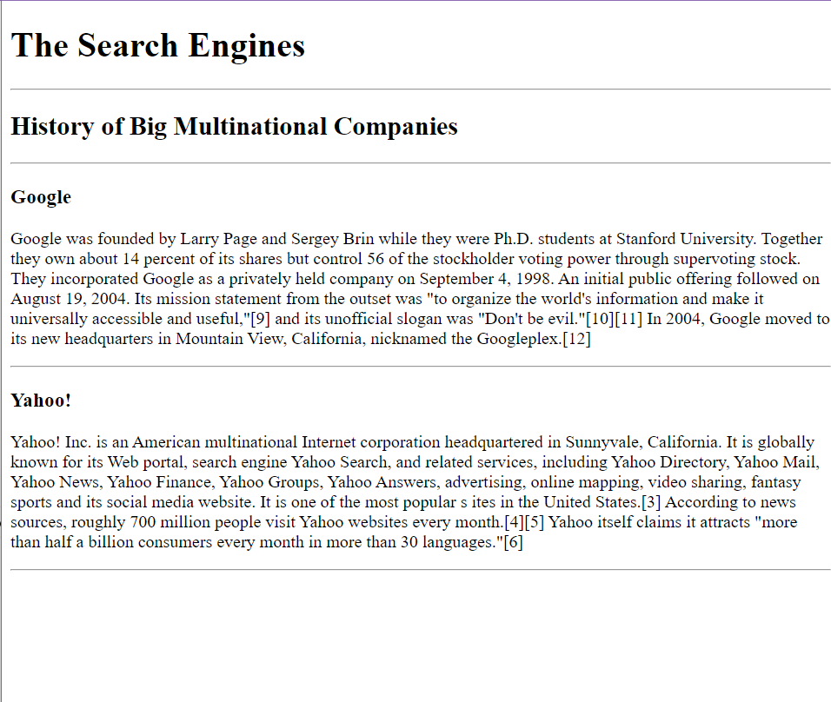

**Html paragraphs:**

The <p> tag defines paragraphs in HTML, and </p> adds a blank line after each paragraph. To create a line break, use the <br> tag.

**Paragraphs code:**

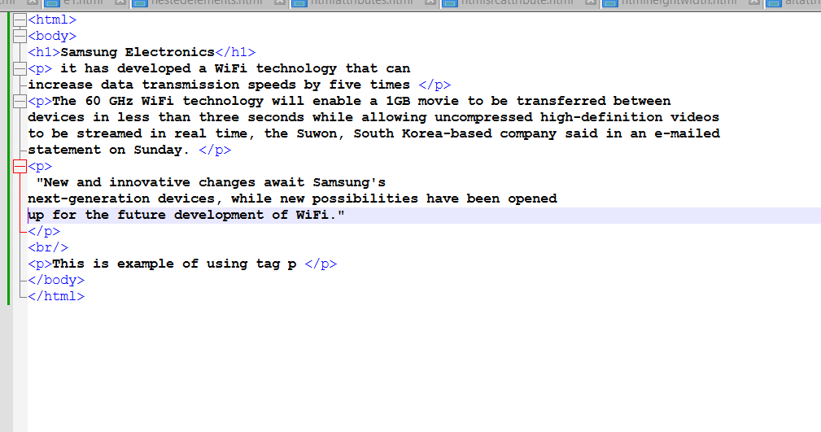

**Output:**

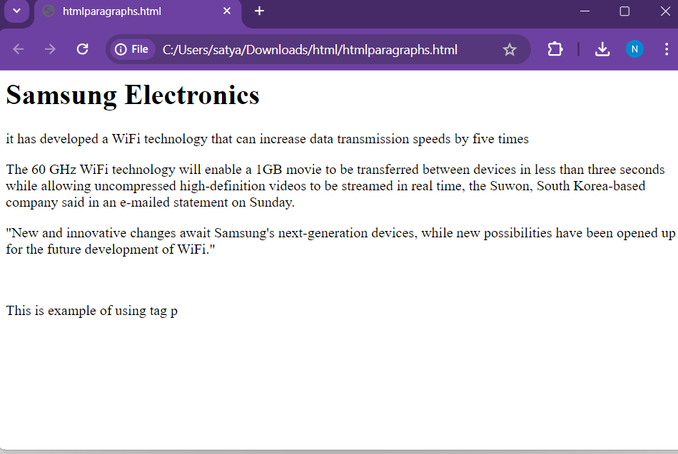

**‘**

**HTML Paragraphs with <pre> tag.:**

The <pre> tag displays pre-formatted text exactly as written in the HTML code, preserving spacing and line breaks.

**Pretag code:**

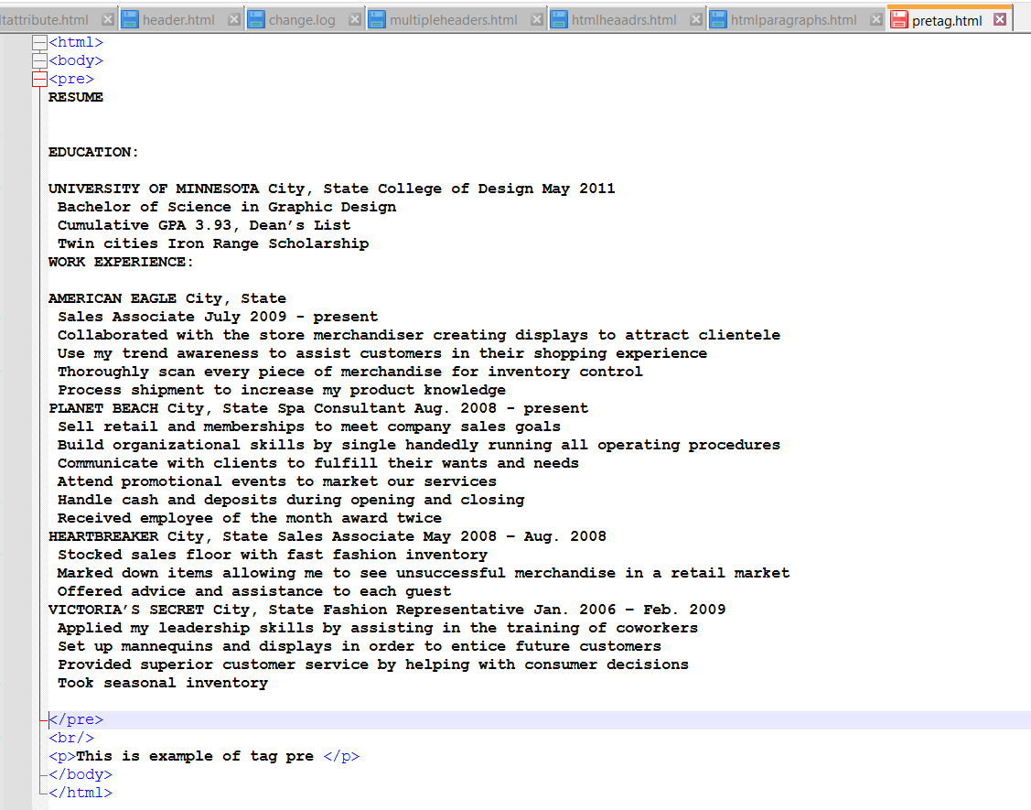

**Output:**

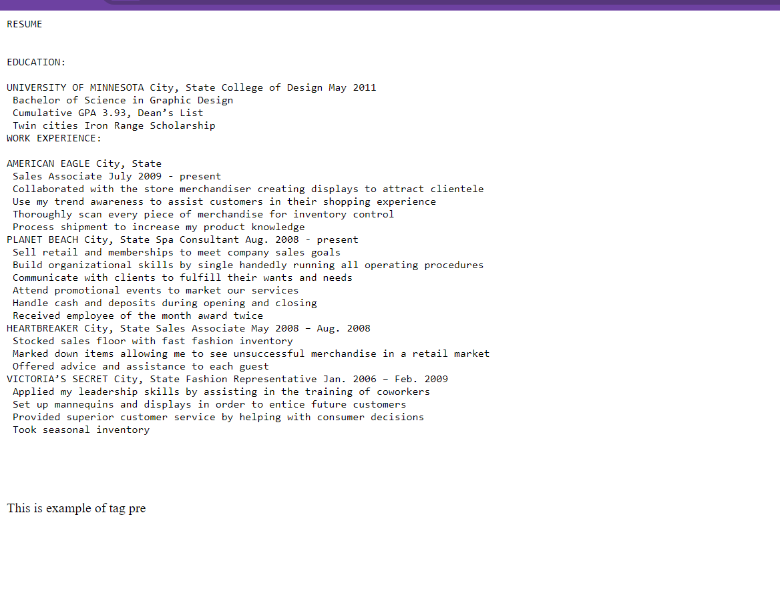

**Some of the tags which can be used for Formatting are:**

<b> - For bold.

<strong> - Emphasized bold

<i> - Italics.

<em> - Emphasized text. Displays in italics but emphasized more.

<mark> - Highlights the text like a highlighter.

<del> - Displays the text and strikes out.

<ins> - Inserted text. Displays text and underlines it as in Word doc.

<sub> - Displays text in Subscript.

<sup> - Displays text in Superscript format

**Boldtag code:**

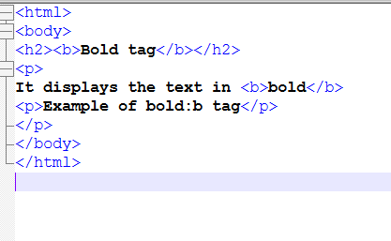

**Output:**

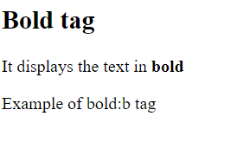

**Italic example code:**

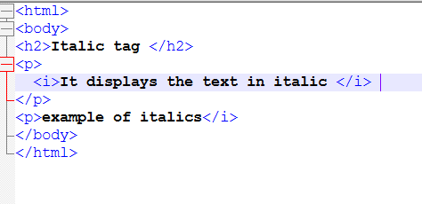

**Output:**

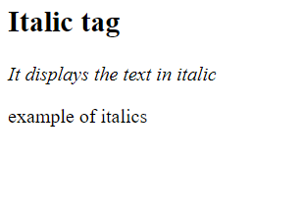

**Mark and delete code:**

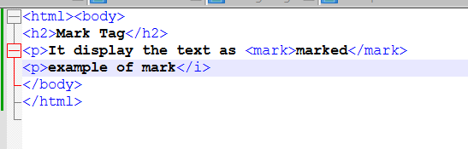

**Output:**

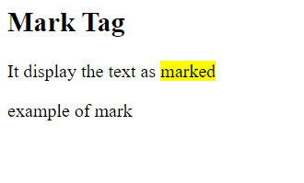

**Delete tag code:**

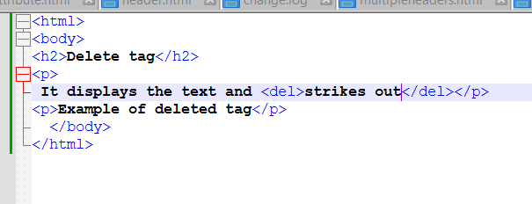

**Output:**

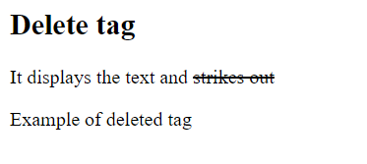

**Html links:**

HTML hyperlinks use the <a> tag. For example:

<a href="http://www.yahoo.com/html/">Yahoo</a>

"Yahoo" is the hyperlink text, and clicking it opens Yahoo's website. The href attribute can link to various file types and URLs.

Linktag code:

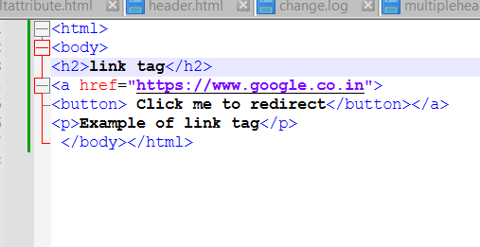

Output:

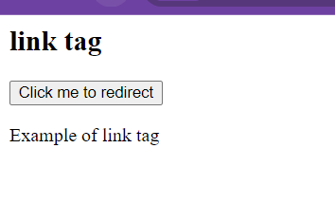

Image hyperlinks:

.